**Simple Interest** – Continually calculated on the initial amount invested and only calculated once per year. The interest is added to the principal amount.

**Compounded Interest** – Interest calculated on the current accumulated amount.

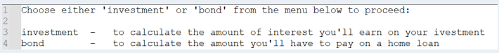

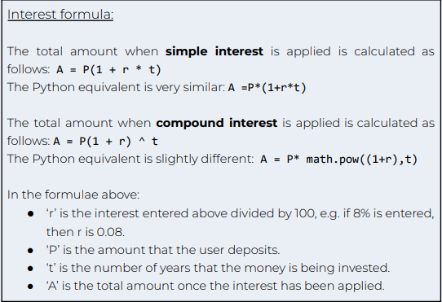

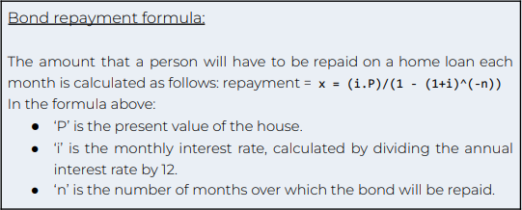

Ask the user to choose which calculation they want to do: investment or bond.

“Investment – to calculate the amount of interest you’ll earn on your investment.”  
“Bond – to calculate the amount you’ll have to pay on a home loan”.

If investment selected Then:

Ask the amount of money being deposited – int   
 The interest rate being used on the investment – percent  
 Number of years planning on investing   
 Ask user if they want simple or compound interest

If simple interest then: A – P(1 + r * t)  
 If compound interest then: A = P(1 + r) ^t   
 *Python can use A = p * math.pow((1+r), t)*

Print answer

Else If bond repayment selected then:

(Repay the amount for each month)   
 Ask the present value of the house   
 Ask for the monthly interest rate   
 Ask the number of months to repay the amount   
 x = (i.p)/(1 – (1+i) ^(-n))